Installation notes for Neurosoft testing

# Machine requirements

1. One, two or three or more machines
   1. Database, web service and client can be installed on separate machines.
   2. Database and web service can be installed on one machine, client on one or more machines.
2. Web service machine:
   1. Windows 7 or similar
   2. With IIS7 turned on (nearly all subfeatures, especially those for WCF)
   3. With IIS7 turned off before installation, the server installer will attempt to install IIS7 but it most probably won’t work.
3. Database machine:
   1. An available SQL Server 2008R2/2012 instance on which to install the database
4. Client machine:
   1. Windows 7 or similar, 32-bit or 64-bit

# Install Holberg SCORE EEG

1. Acquire Holberg SCORE EEG zip file from Holberg EEG (Dropbox or similar)
2. Unzip “HolbergFull_NeurosoftOnly.zip” somewhere
3. In the ServerInstall subdirectory of this zip,run “HolbergSCOREEEGServerSetup.exe”
   1. Accept the license agreement, click Next
   2. In the custom features screen, let the default selections “Web service” and “Database” alone.
      1. If you want the database on one machine, and the web service on another, then run this installer on each machine separately. Deselect the feature that is not needed, so that on the database-only machine, you install the database only and on the webservice-only machine, you install the web service.
   3. In the database specification screen, enter the name of a SQL Server Instance. Currently, you must use “Windows authentication” to access the server. Click next.
      1. If you must specify a username and password for the database login, you must then manually modify the connection string in the web.config in the \inetpub\wwwroot\HolbergWebservice directory on the web service machine.
   4. Click Install, wait and click Finish.
4. In the Client subdirectory of this zip, run “HolbergSCOREClientFullSetup_MicromedOnly.exe”
   1. Accept the license agreement, click Next.
   2. In the web service selection screen, select “local with HTTP” and enter the name of the web server. For a single PC setup, this is “localhost”. Click next.
   3. Click Install, wait and click Finish.
5. You can now start the Holberg SCORE client from the Start menu.

# Install Neurosoft Neuron-Spectrum.Net ω

1. Install it using the Installer, acknowledging and accepting all questions.
2. Acquire a set of demo EEGs.

# Set up the Holberg SCORE EEG and Neurosoft integration

1. Start the Holberg SCORE EEG client using the default username “doc1” and password “score99”
2. Click on the top tap “Administration”.
3. Click on the lower left panel “External EEG”.
4. In the middle left content panel, click “Neurosoft”.
   1. Verify that the Program Files path to Neurosoft.EEG.WPF.exe listed in the large middle panel is correct.
5. Click on the button “Add database”.
   1. Enter name “Test”, display name “Test” , server “.”
   2. Click Save.
   3. A screen shot is seen here:
   4. 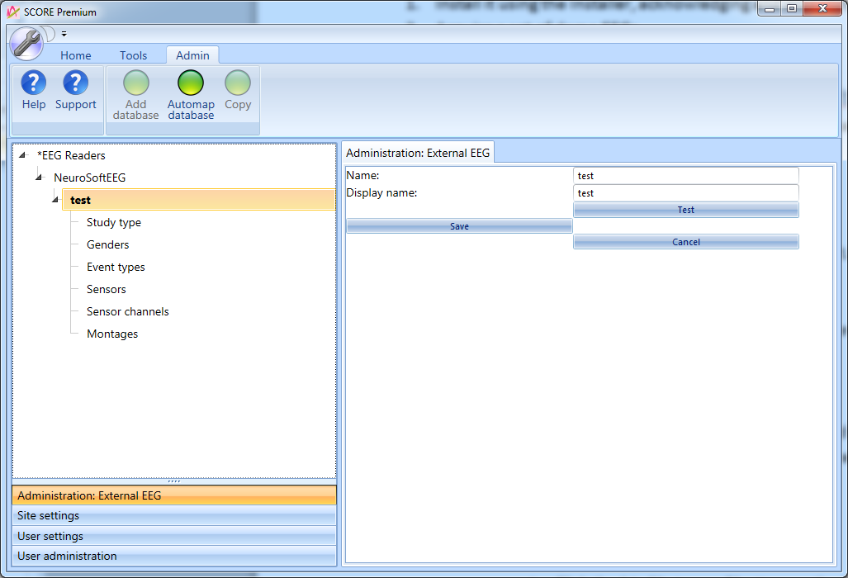
6. Then map the Micromed data to SCORE data:
   1. In the big content panel , click “Study type” and map it as follows:
      1. In the big content panel, click study type «StandartEEG» in the column unmapped external.
      2. Click “Standard EEG” in the column Internal.
      3. Click the “Map” button.
      4. Repeat for the other study types so that it looks like this: 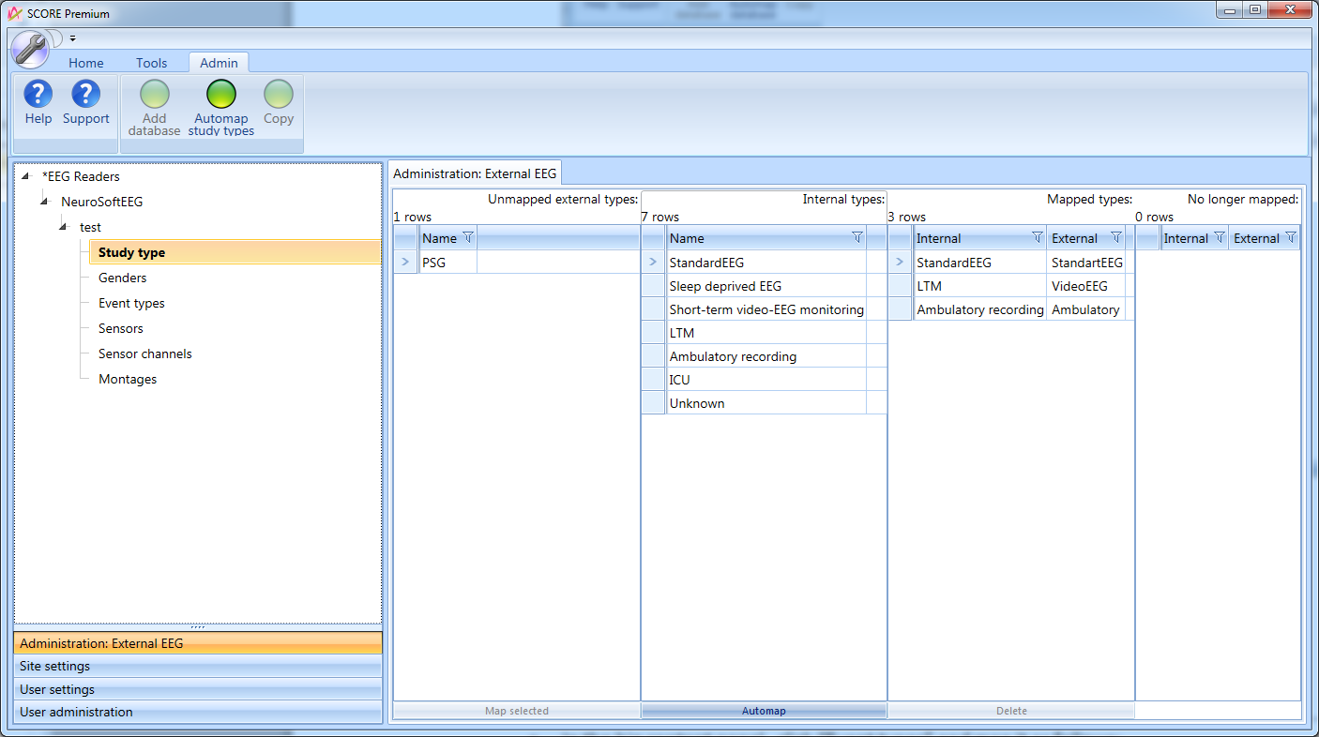
   2. In the big content panel , click “Genders”.
      1. Click the big “Automap” button on the buttons row.
   3. In the big content panel , click “Event types” and map it as follows:
      1. In the big content panel, click event type «eventComment» in the column unmapped external.
      2. Click “Graphoelement” in the column Internal.
      3. Click the “Map” button.

# Test drive the integration

1. Import studies as follows:
   1. In the SCORE client, click the “Home” tab at the top.
   2. Click “Workflow” in the left lower panel.
   3. In the lower right panel, select reader “NeuroSoftEEG”, then database “test”.
   4. Enter from date as 1.1.2000 and leave “To date” alone.
   5. Click import.
      1. THIS CRASHES due to a NullReferenceException in the method GetImportCount.